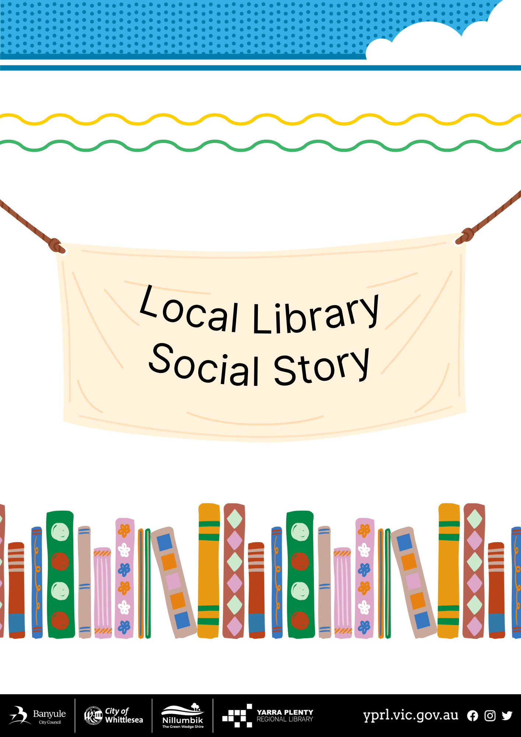

**Mill Park Social Story**

|  |  |
| --- | --- |
| I am going to visit Mill Park Library. |  |
| We will look at books. |  |
| We might listen to songs and stories. |  |
| These are the toilets. I can use them if I need to. |  |
| We can use the computers. |  |
| We can visit the café for some food or drink. |  |
| The library is a quiet place. |  |
| We can go outside and enjoy the garden. |  |
| We might borrow some books to take home with us. |  |
| We can return our books when we come back next time. |  |