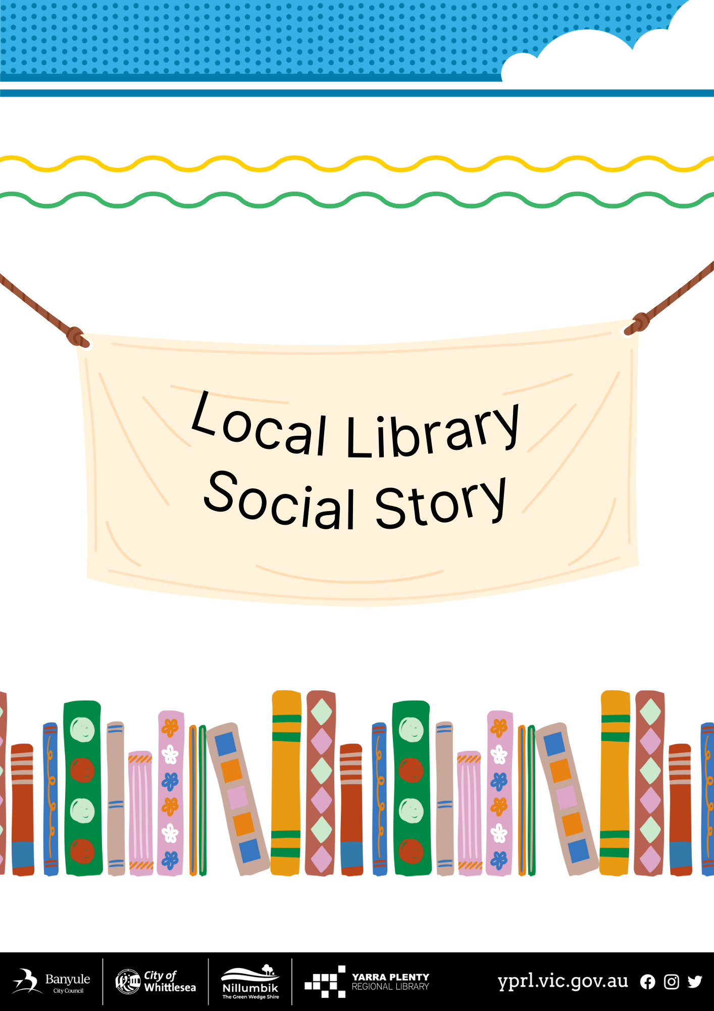
Social Story – My Visit to Ivanhoe Library and Cultural Hub

I am going to Ivanhoe Library and Cultural Hub.  It is a very big building. | 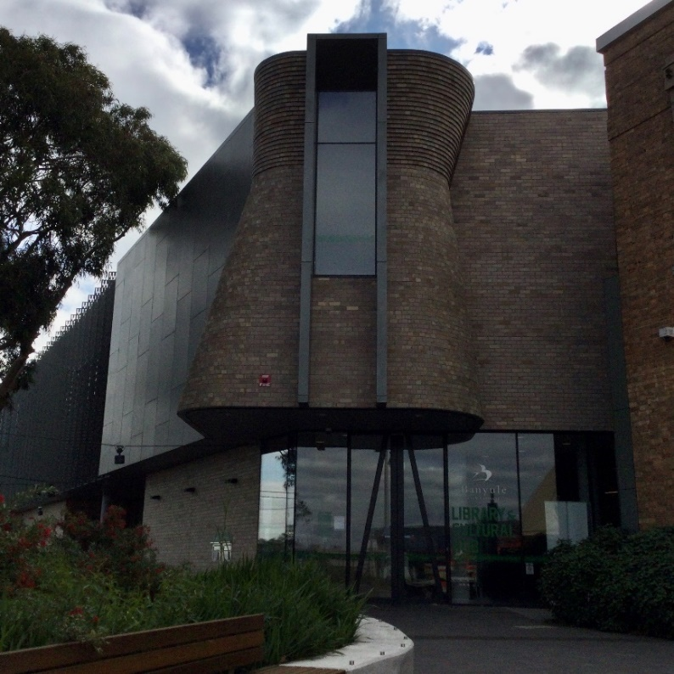
I can return my books through the returns chute outside of the library | 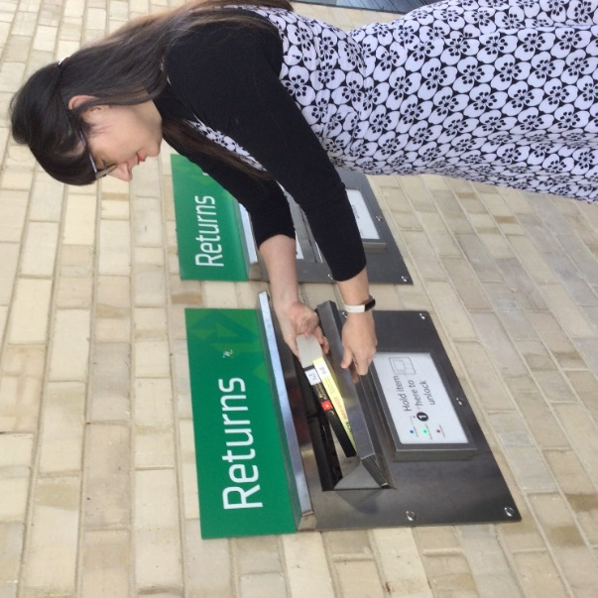
I will go through two sets of doors to go inside. The doors will open automatically when I get close. | 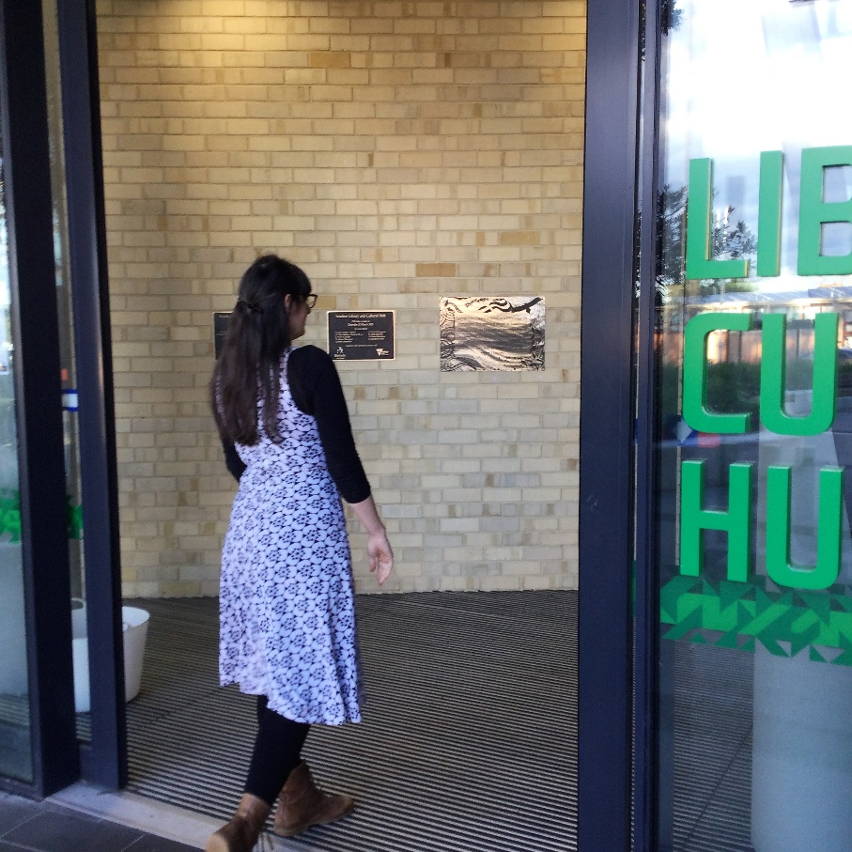
In the foyer is a small desk where the librarian works.  There is a bigger desk for the people who work for Banyule City Council. | 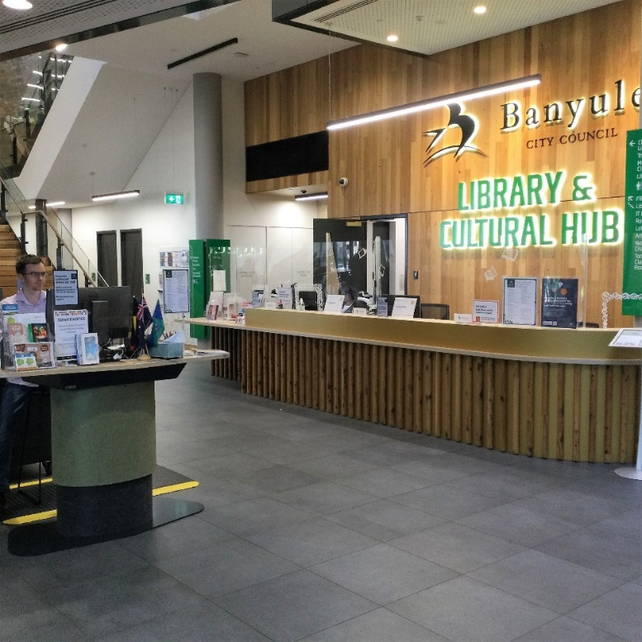
The librarians wear nametags. They can help me if I have any questions. | 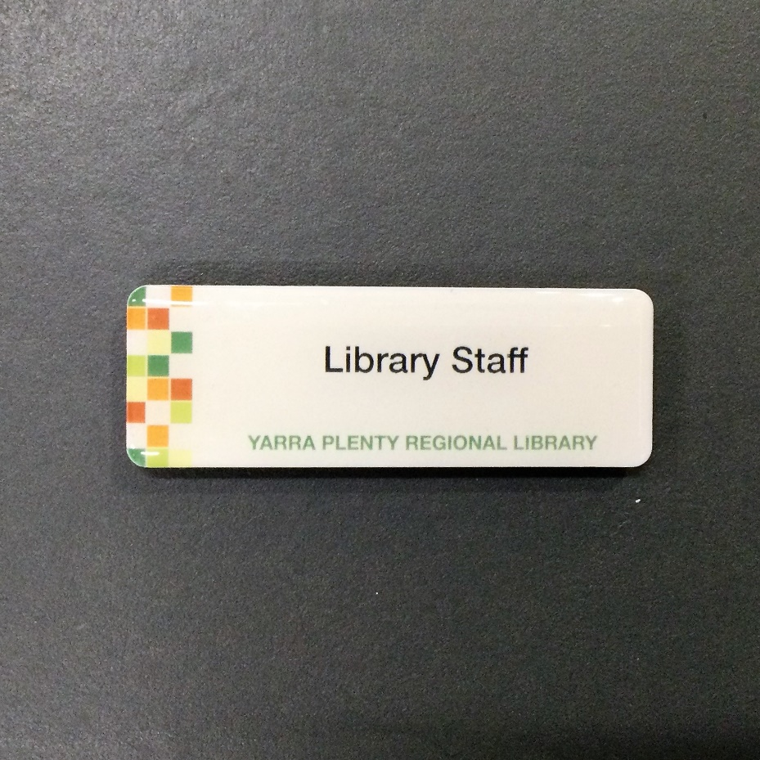
I can join the library at the foyer desk and get my own library card. I will need identification | 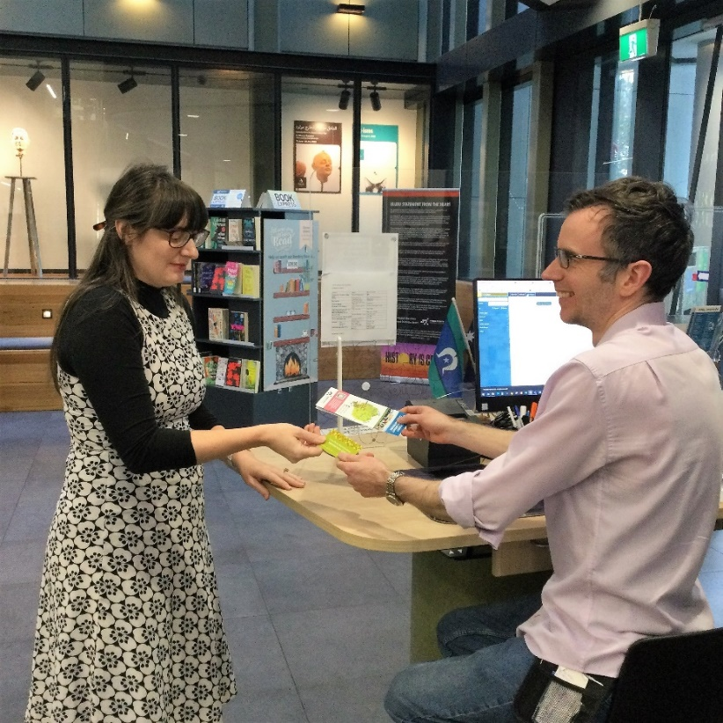
Books on reserve for people are to the left-hand side of the foyer desk.  They are sorted by people’s last names. If there is a reservation for me, it will have a slip of paper with my last name on it. | 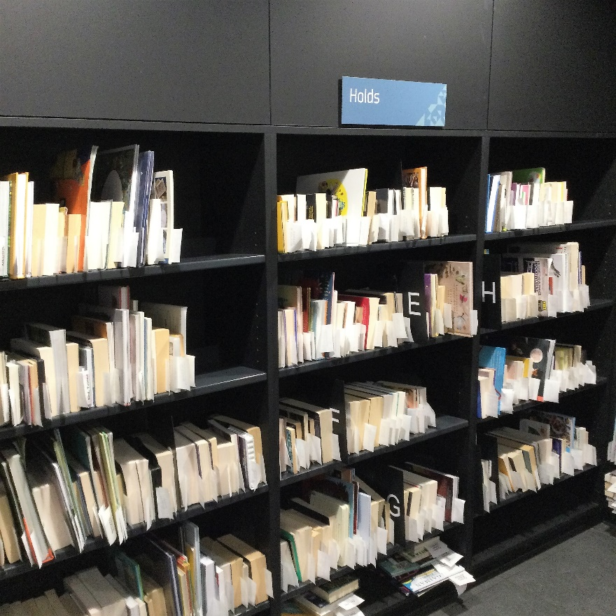
There are some shelves at the front of the library with new and popular books. | 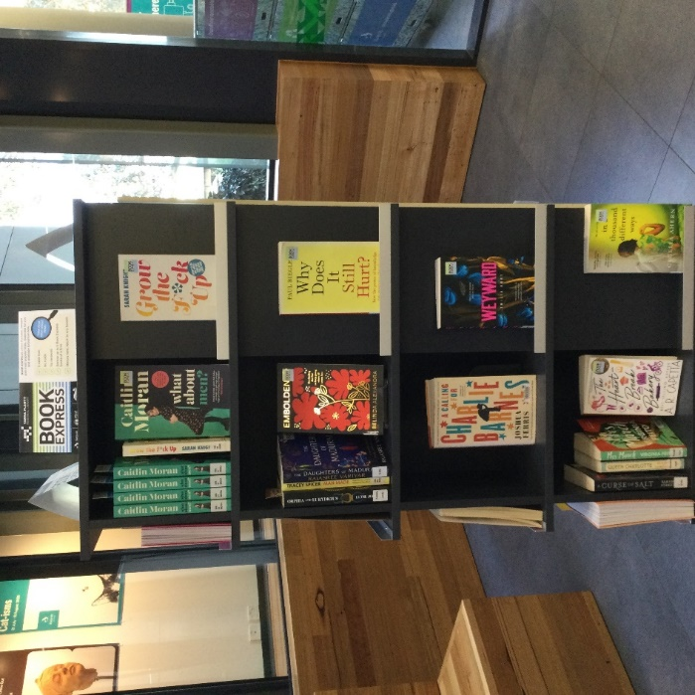
Past the foyer is the main staircase to the upper level. | 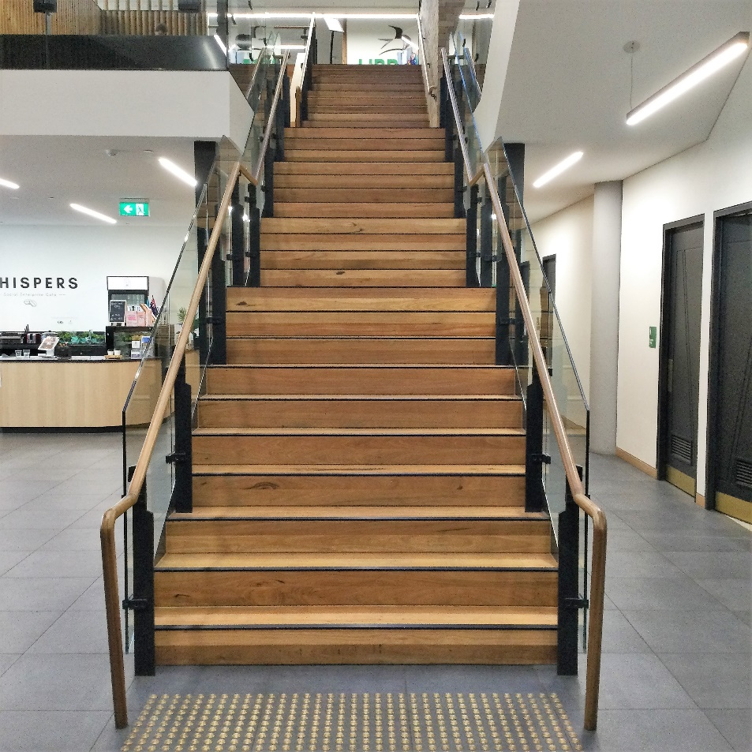
There are public toilets just to the right of the main staircase. | 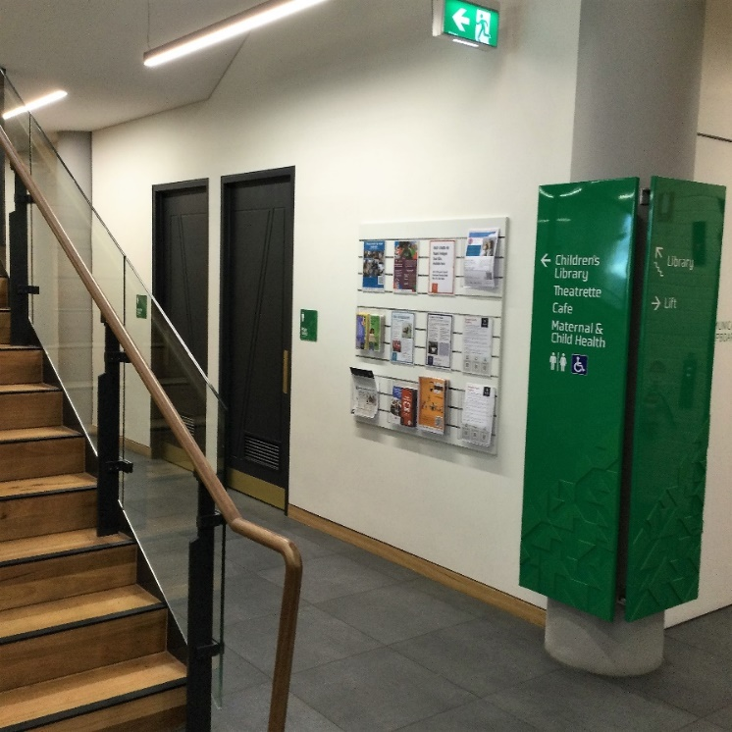
Left of the main staircase is the café. There is a coffee machine and people talking. It is loud. | 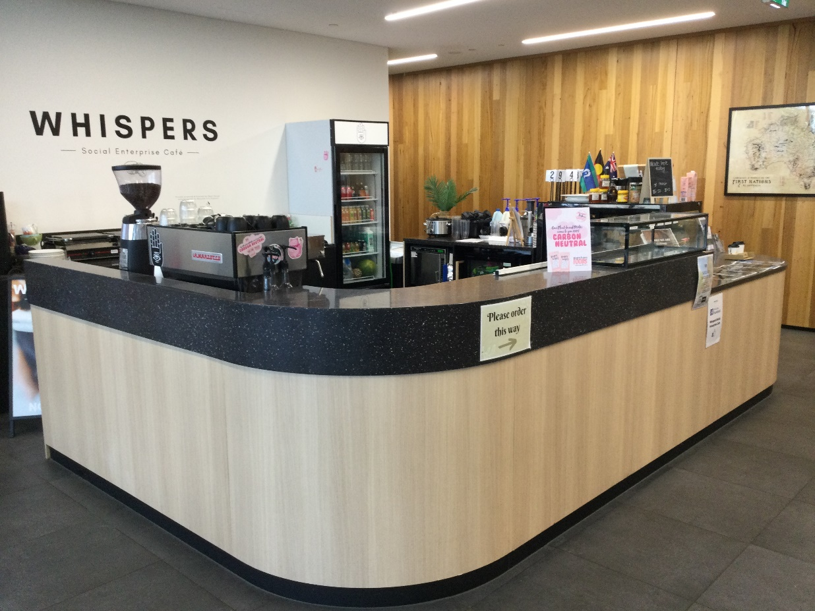
Today’s newspapers are out on a table at the café for everyone to read. | 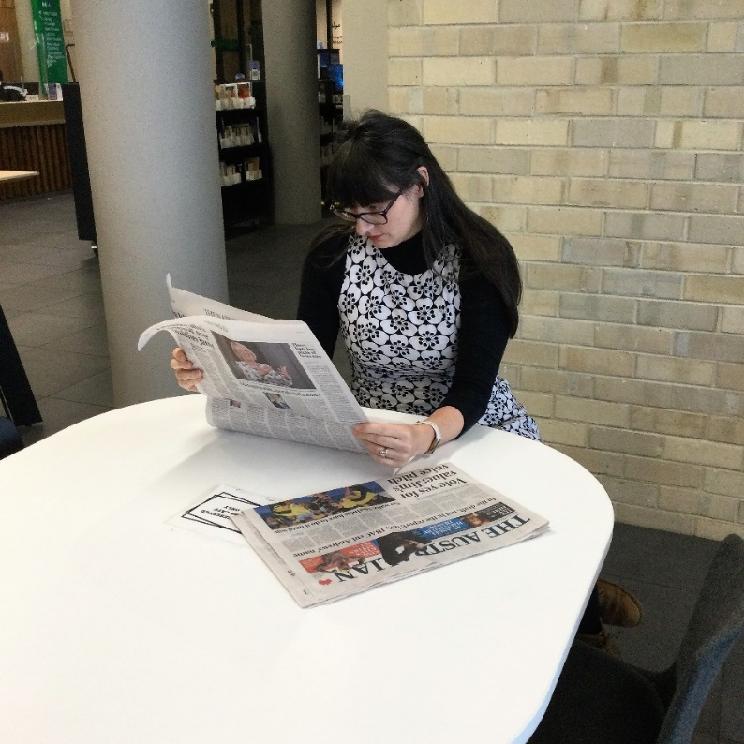
There is another entrance to the library near the café. | 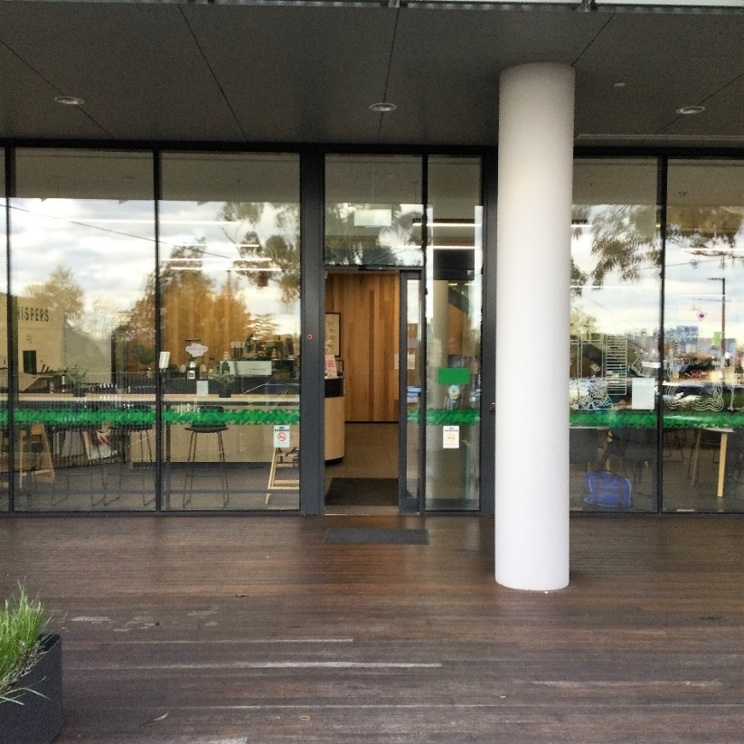
There is a Prayer room/quiet space next to the stairs where I can go if I feel overwhelmed. | 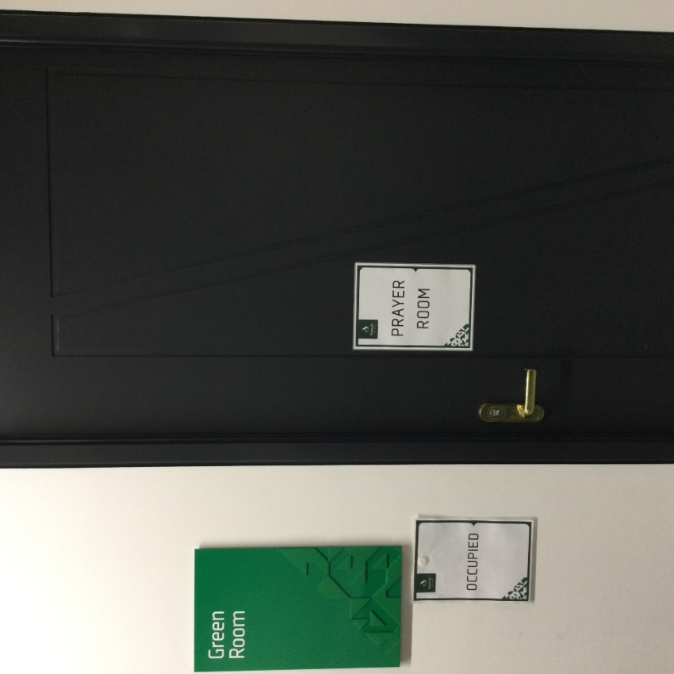
Further down the corridor past the café is the theatrette. Storytime happens here. Storytime is fun, but noisy. | 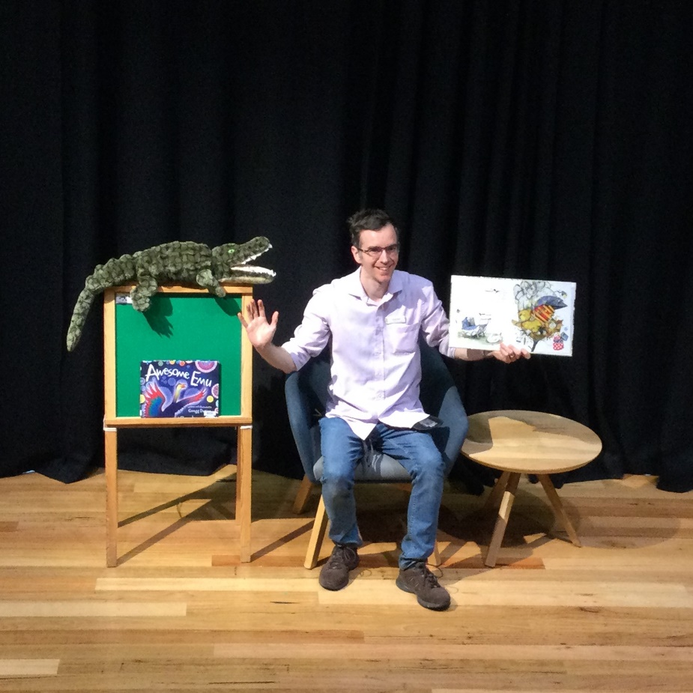
Past the theatrette is the children’s area. I can pick-out some books to borrow. | 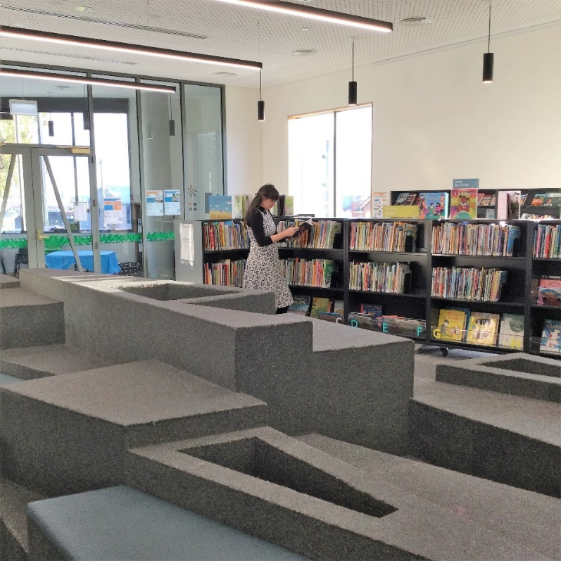
I can go upstairs by climbing the staircase. I can also go up in the lift to the right of the main stairs. | 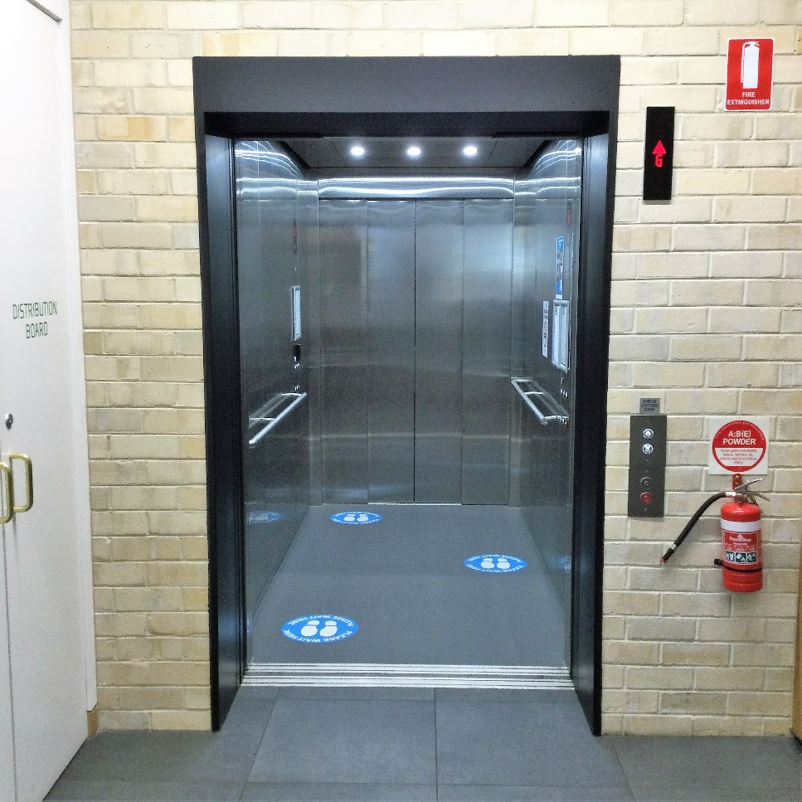
Upstairs is another information desk where I can ask the librarians questions. | 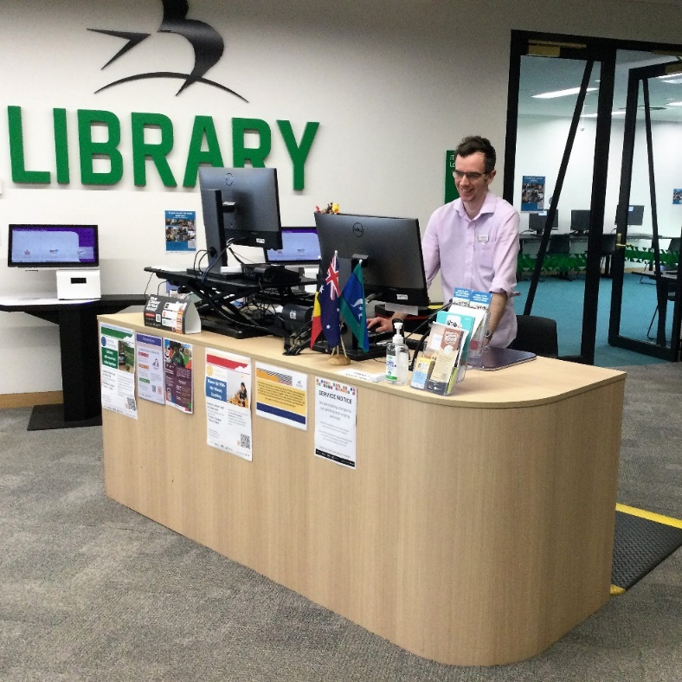
Behind the information desk is the young adult area. It has books and graphic novels and some booths to sit at. | 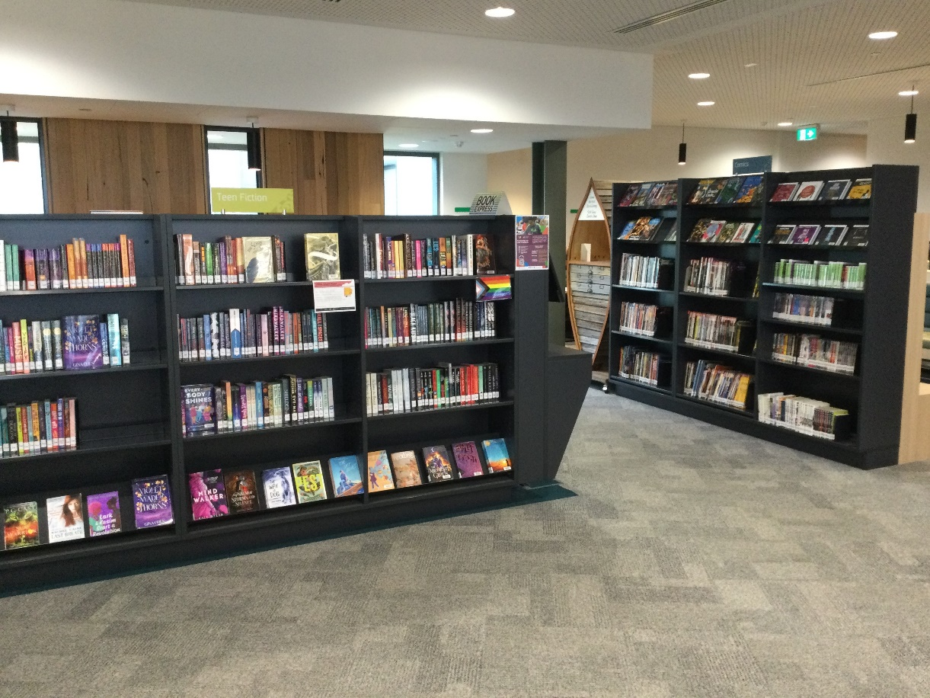
Near the information desk is a television with a Nintendo switch and a PlayStation 5. The games can be loud. | 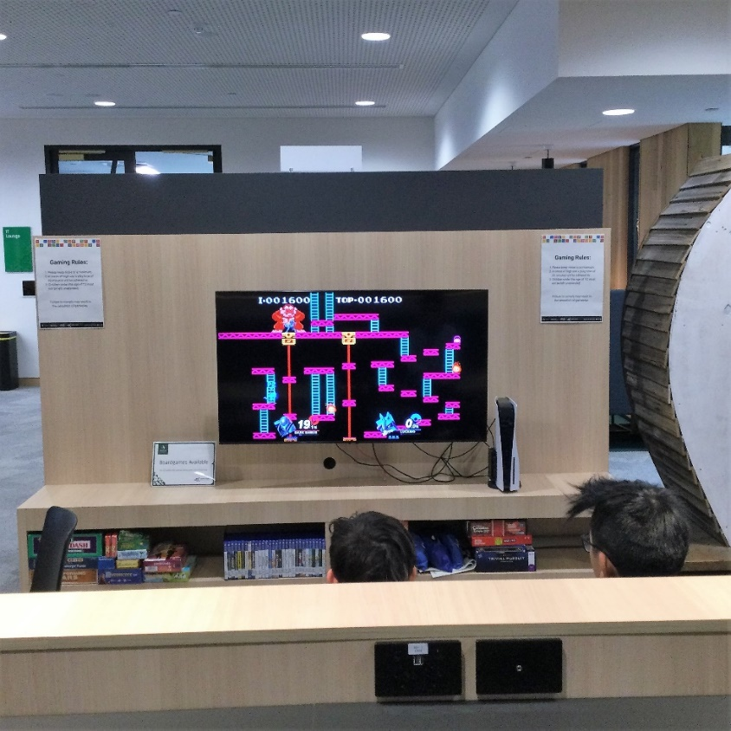
There is a computer room where people can access the internet. I will be quiet in here and keep the volume low on the computers. | 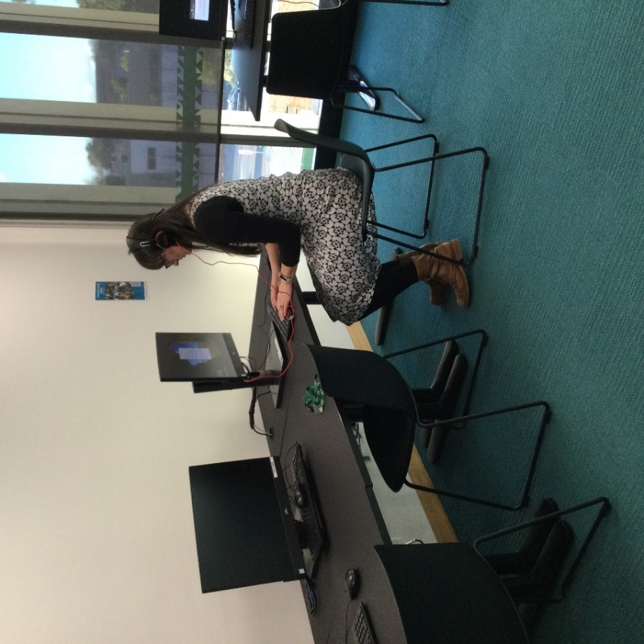
There is a photocopier in the library for people to print, photocopy and scan. It can be noisy when in operation. | 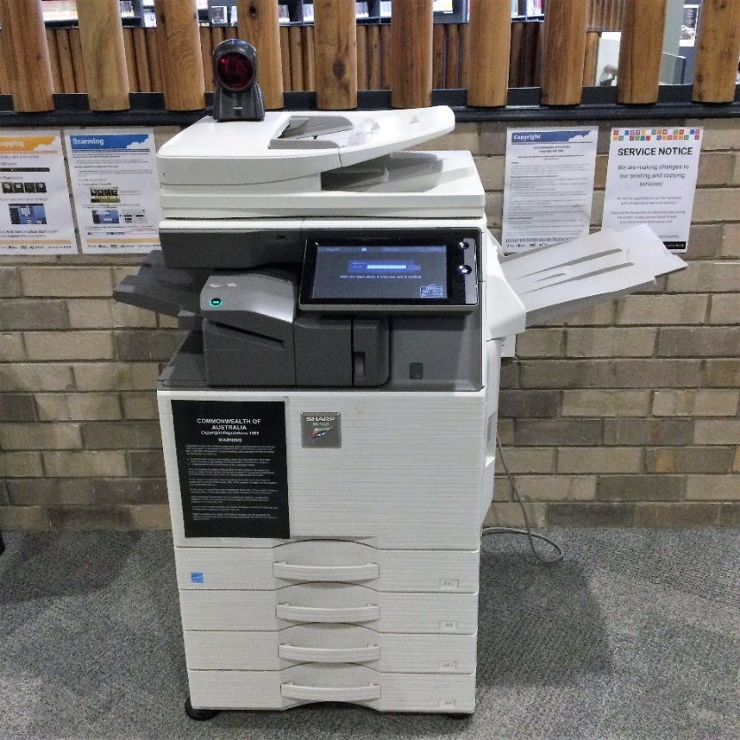
There is a Makerspace with a 3D printer and laser cutter. People need to complete training to use these. | 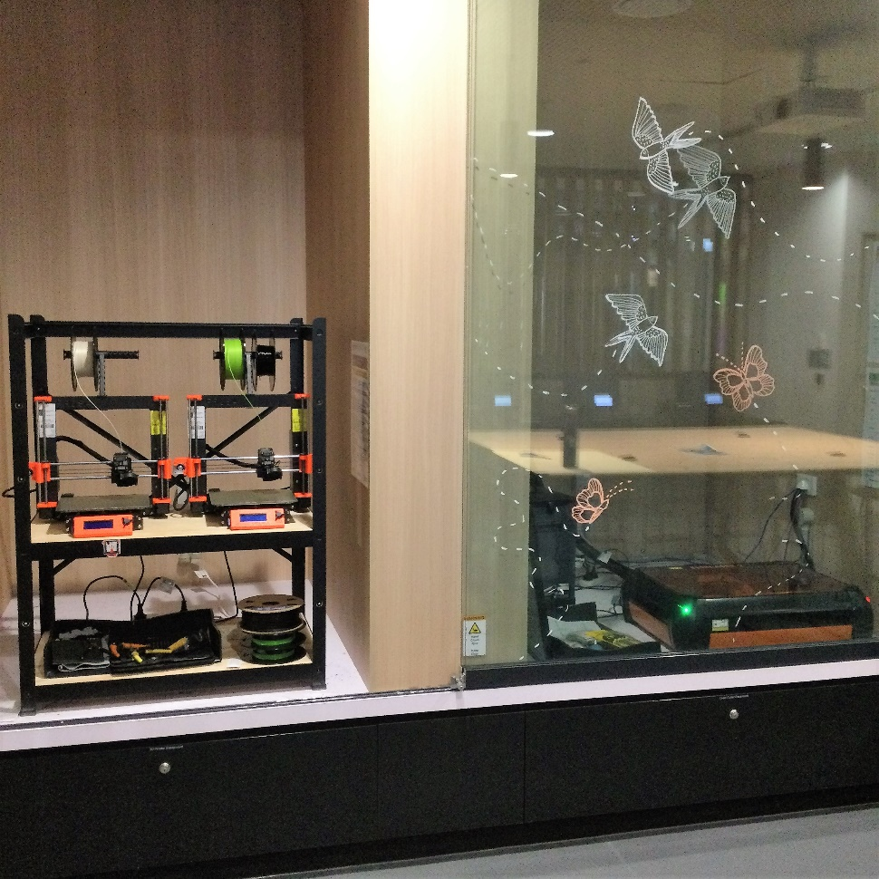
There are collections of fiction and non-fiction books and DVDs to borrow. | 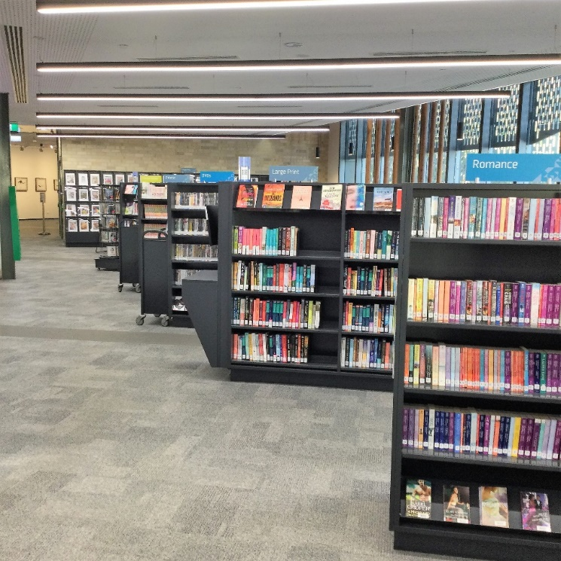
I can look up books I want to find on the catalogue computers that are on the end of some of the shelves. | 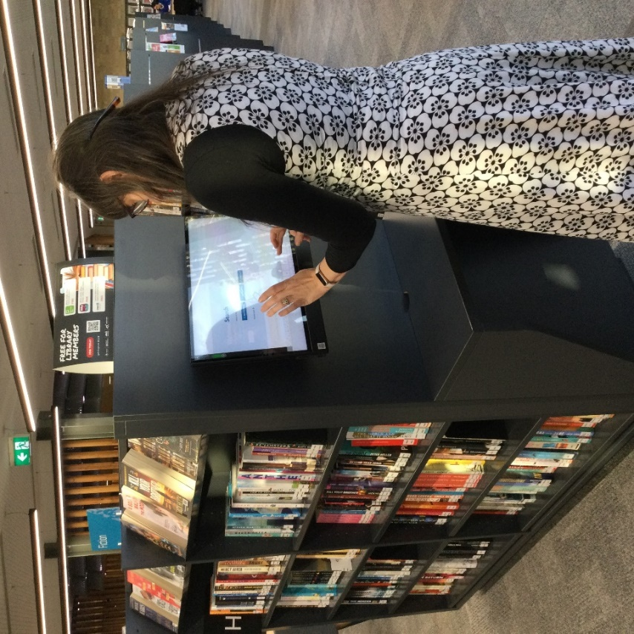
There are tables to read or study at. | 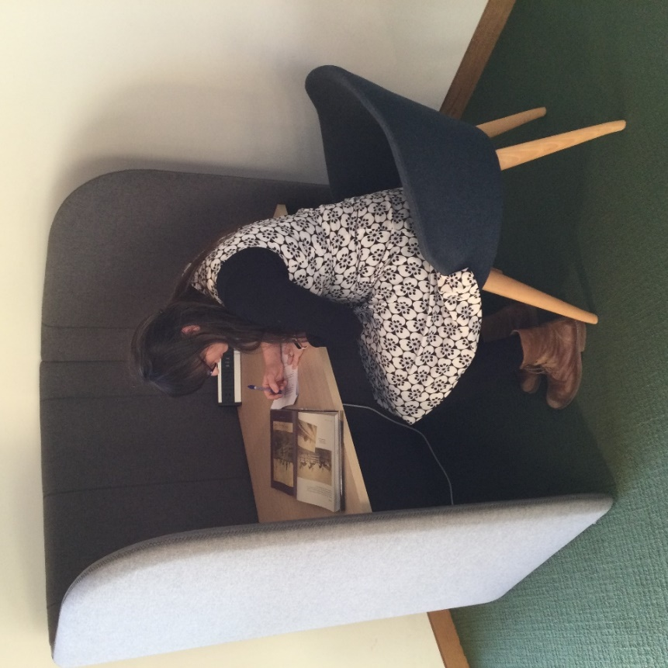
Just past the magazine area is Loft 275.  Art exhibitions display in here and sometimes they have music or sound effects playing. | 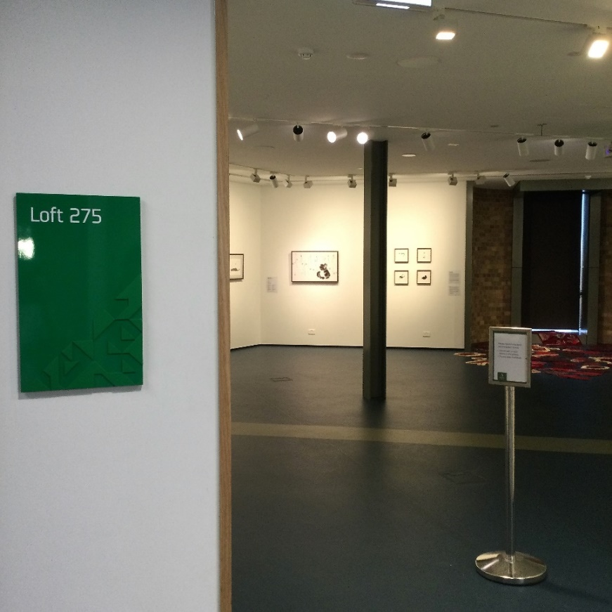
There are some quiet study rooms. I must book these to use them. | 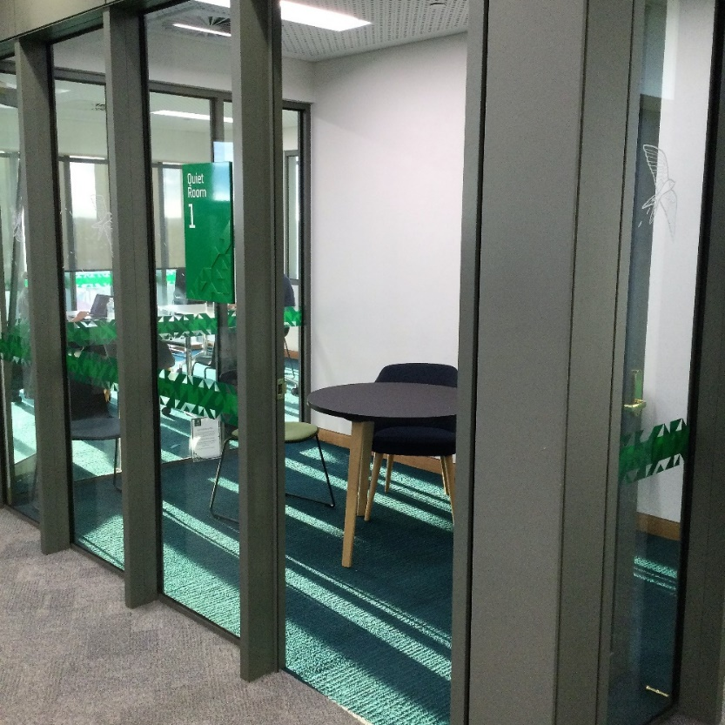
There is free Library Public Wi-fi that I can use to access the internet on my own device.
I can go outside onto the deck. | 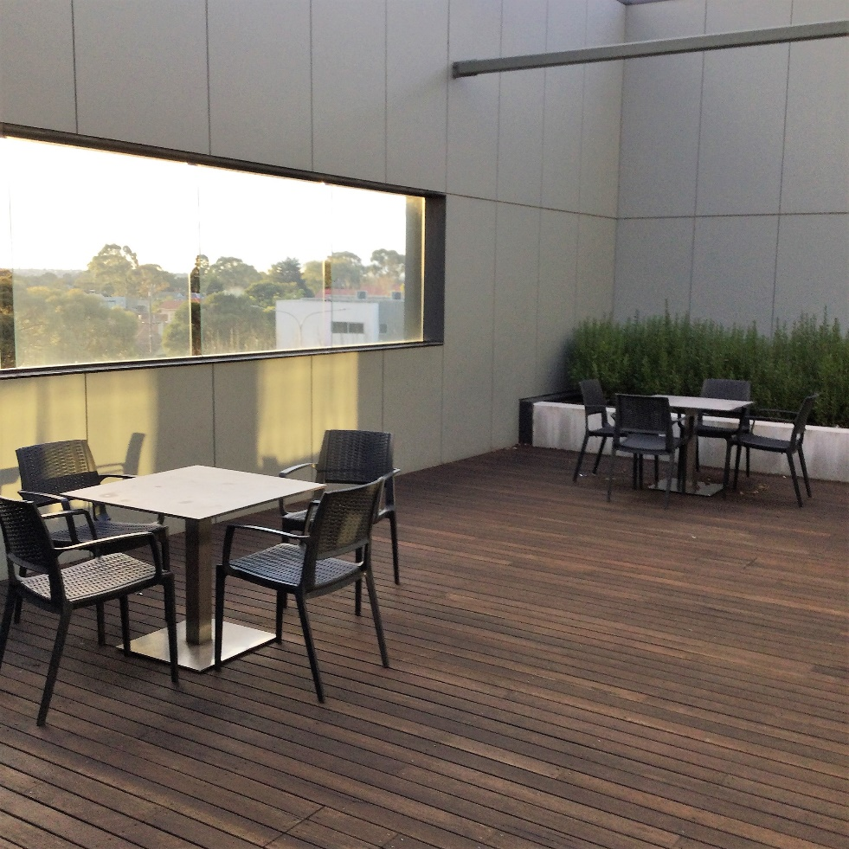
There is a Local History room with many old books. | 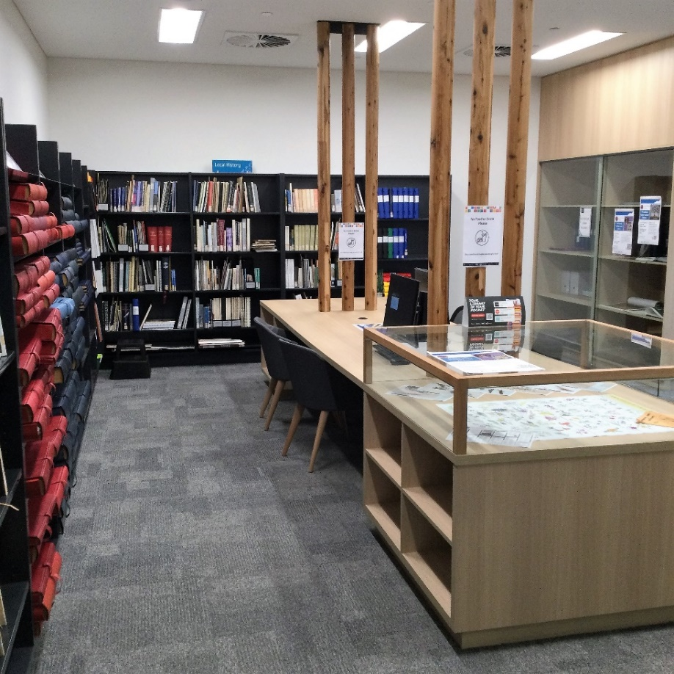
There is an Artist’s studio.  Sometimes I might see an artist here. I can ask them questions about their work. | 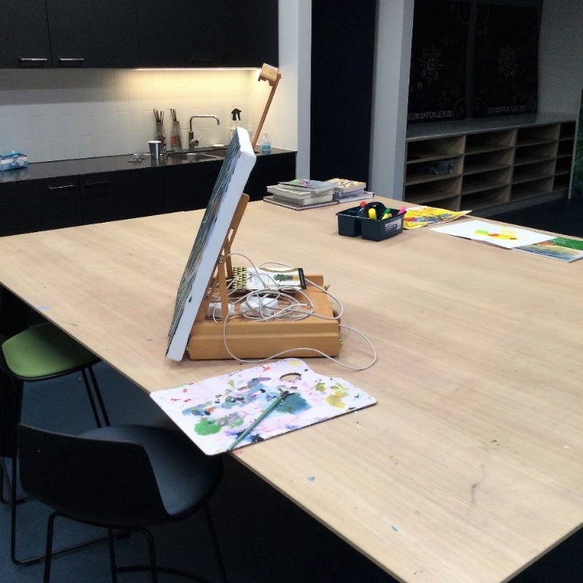
I can borrow items myself from the self-checkout machines. | 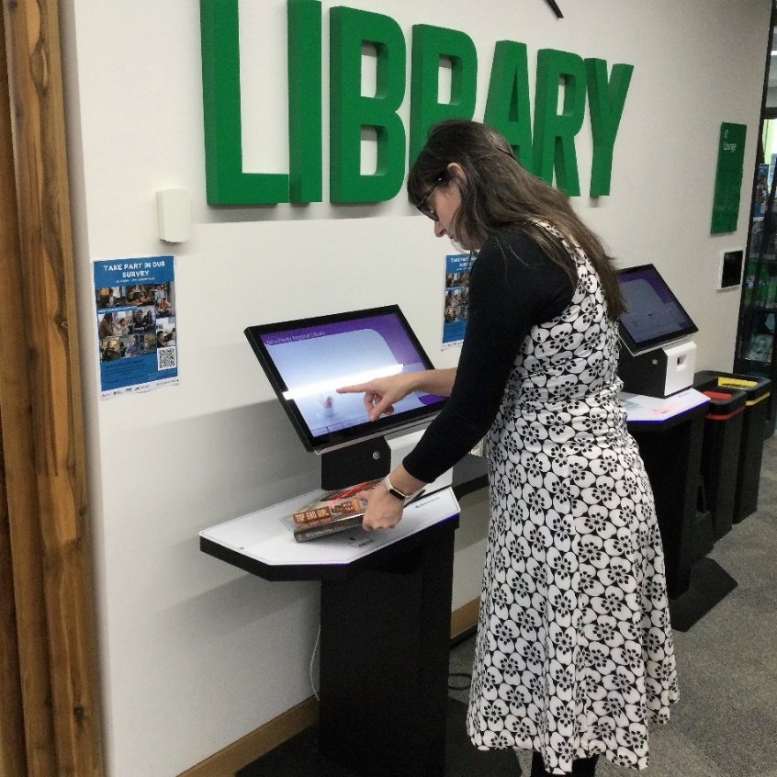
When I leave, I will say good-bye to the librarians. | 