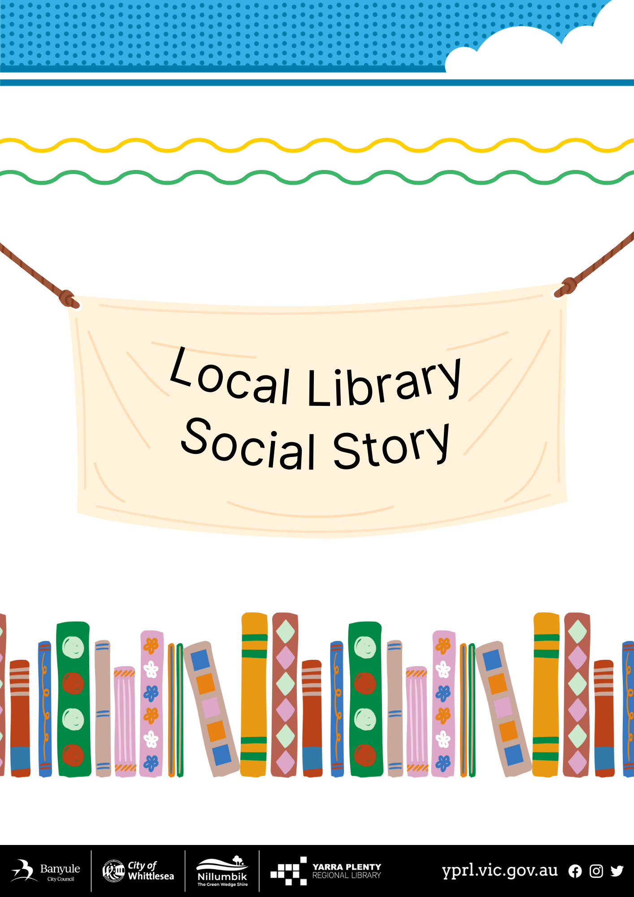
My visit to the Mobile Library
The Mobile Library has 13 locations I can visit | 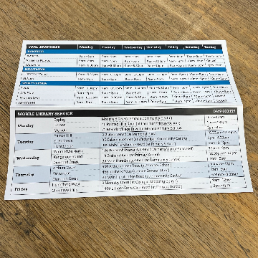
This is the Mobile Library I will be visiting | 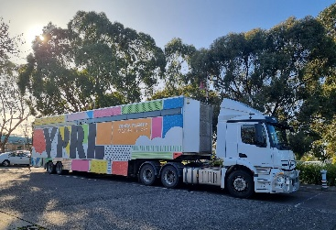
You enter the Mobile Library via the stairs. Hold onto the yellow handrail and walk up the stairs. | 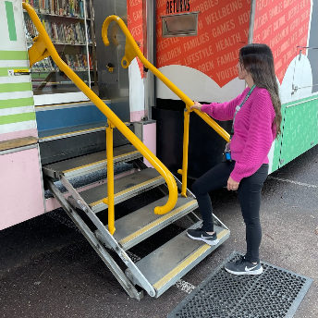
I can return books through the chute on my right.
In front of you there is an automatic glass door which will open once you are close to it. | 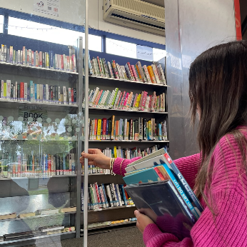
When I walk in on my right there is another returns chute. | 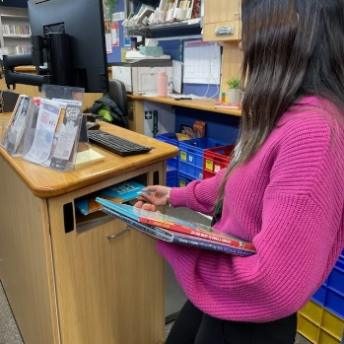
Library staff wear name tags/lanyards and will greet me once I am inside. | 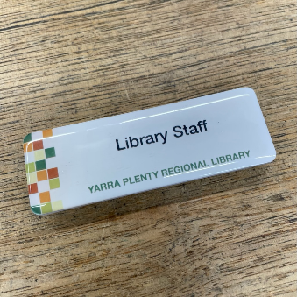
There are Library staff at the desk who I can ask any questions to and ask for help if needed. | 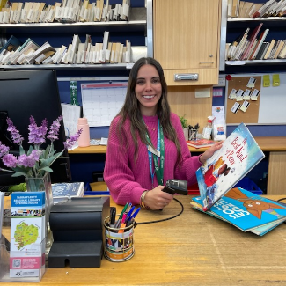
Holds are kept behind the desk, I need to ask a library staff to collect mine.
The children’s area is split level, so please watch your step. | 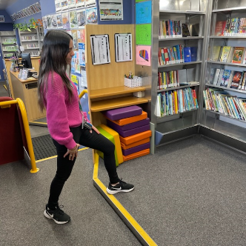
There are colouring in sheets and pencils feel free to do one here or take one home. | 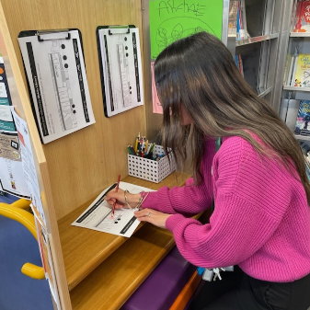
There are cushions I can sit on while I read a book. | 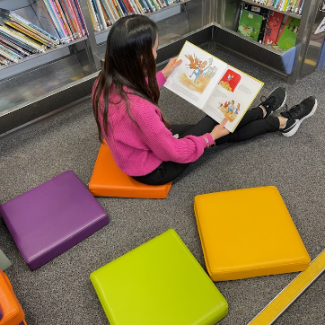
There are lots of shelves of books to browse. | 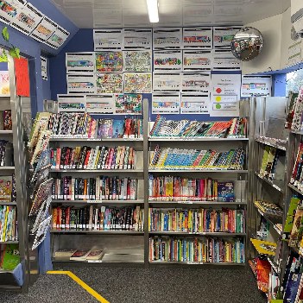
There are a lot of displays I can choose from. | 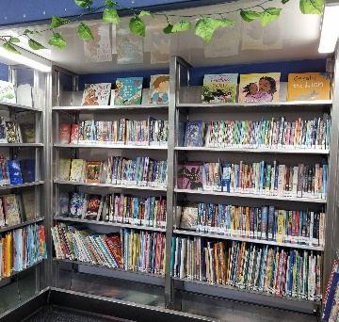
There is a big red seat I can sit on if I need a rest/read a book. | 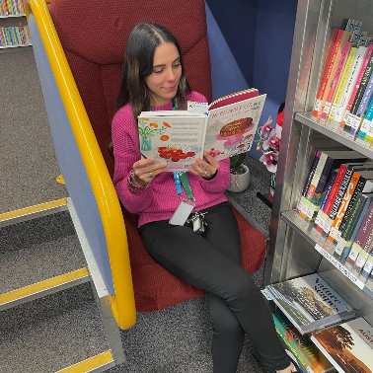
I will find adult fiction and non-fiction, dvds, magazines and audiobooks. | 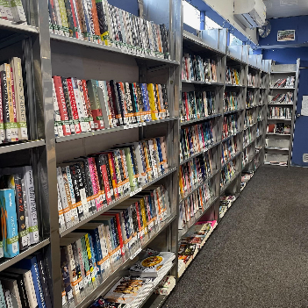
I can also access public computers or have a seat If I need a rest/read a book. | 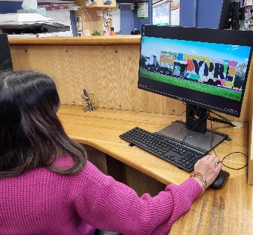
I take the items I want to borrow to the desk as the library staff will scan my items for me. | 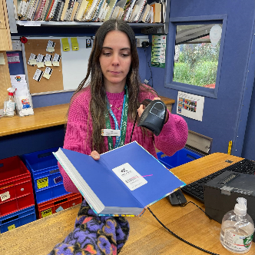
We hope to see you again soon on the Mobile Library | 