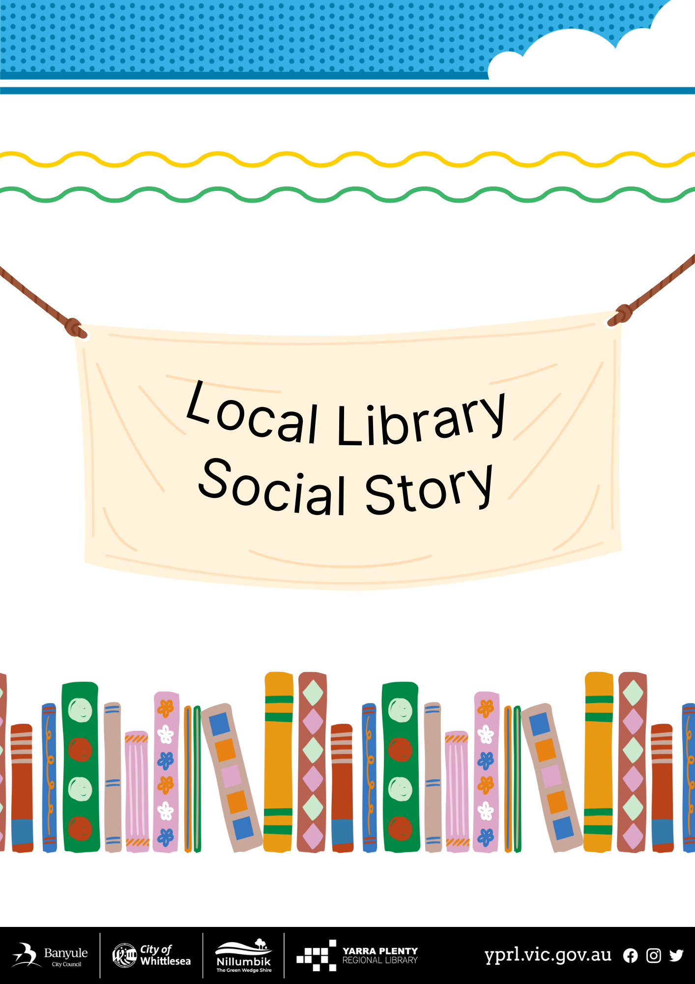

Social Story – My Visit to Lalor Library

I am going to visit the Lalor Library. | 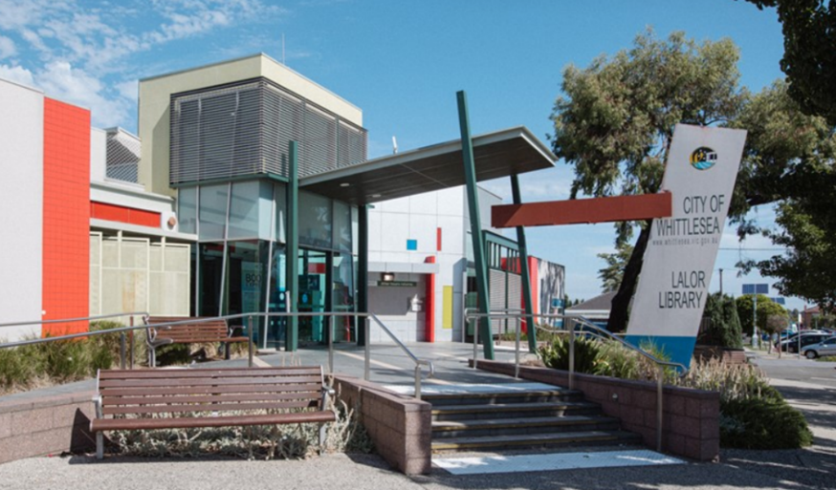
The door will open automatically when I get close. You will need to enter two automatic doors before you are inside Lalor Library. | 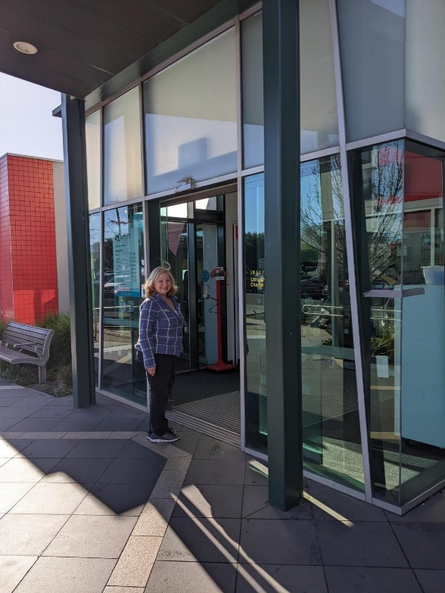
I can return my books in the book chute before I enter the library. | 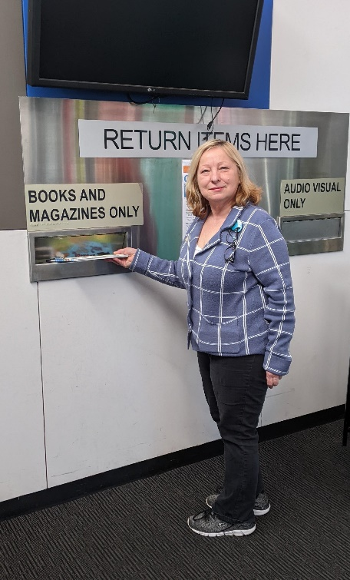
The final door to enter the library is another automatic door. | 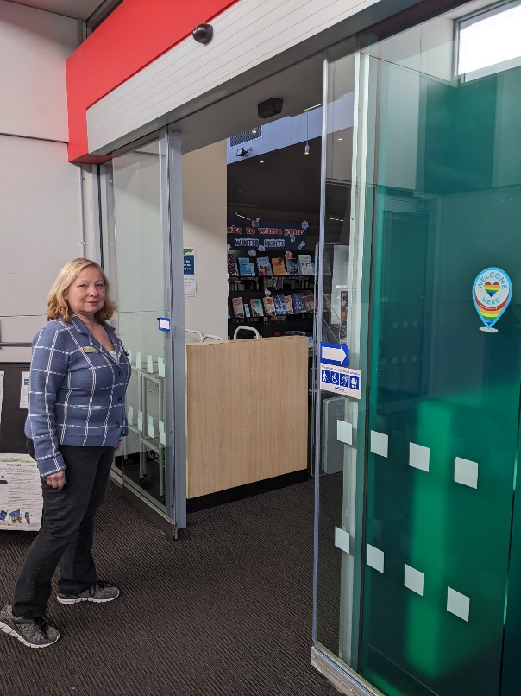
The librarians wear nametags. They can help me if I have any questions. | 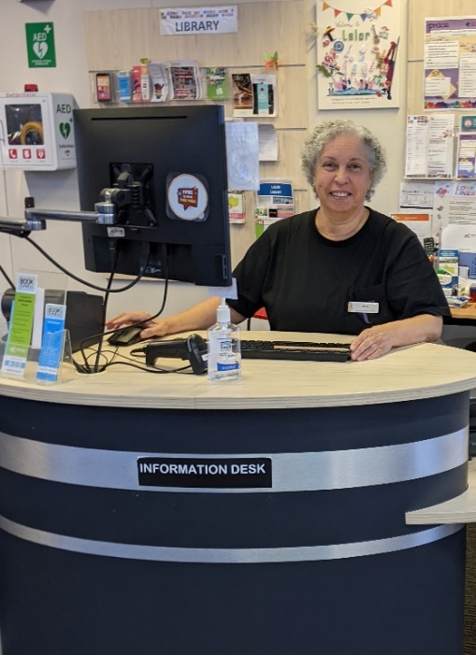
I can join the library at the information desk and get my own library card. | 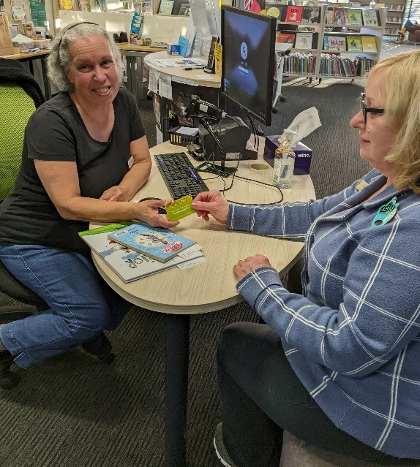
Books on reserve for people are on the left-hand side shelving as you enter the library. They are sorted by peoples’ last names. If there is a reservation for me, it will have a slip of paper with my name on it. | 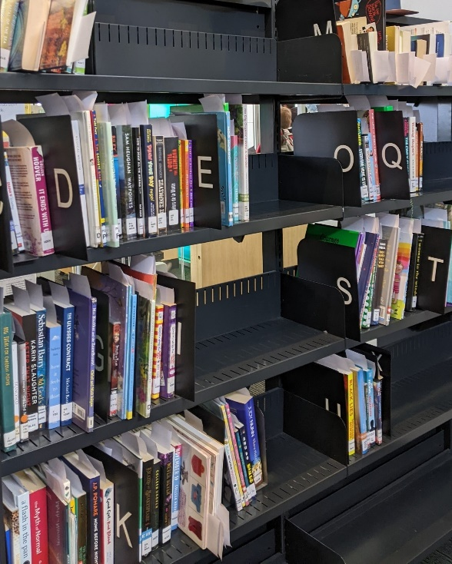
There are some shelves with new and popular books when you go past the information pods.
I can visit the children’s area and pick-out some books to borrow. | 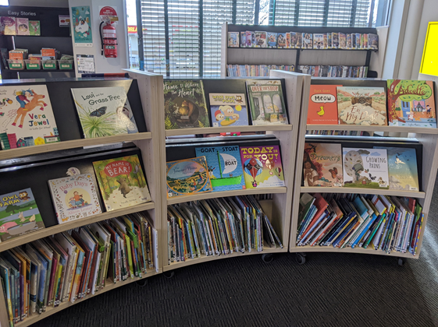
Storytimes can be noisy with singing and rhymes. | 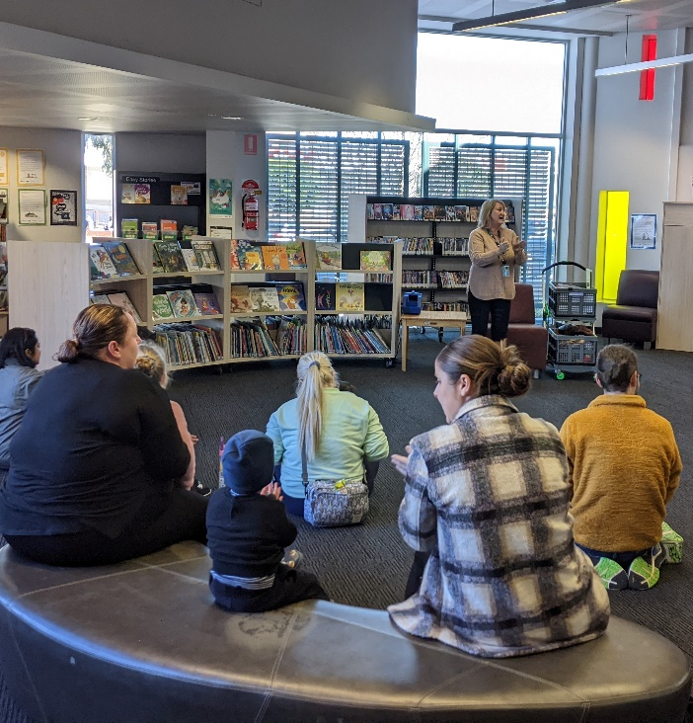
We have a Toy Library as well which is open for one hour after each storytime.  You can borrow up to three toys with your library card. | 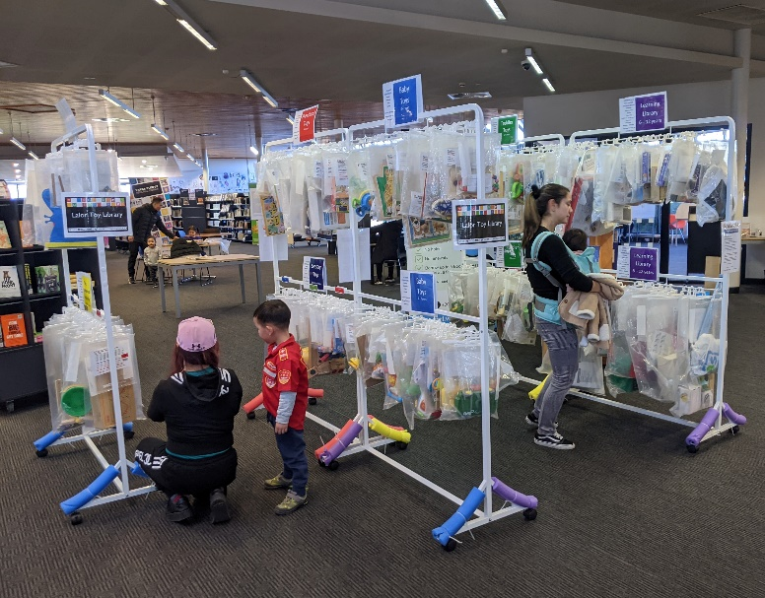
There is a photocopier in the library for people to print, photocopy and scan. It can be noisy when in operation. | 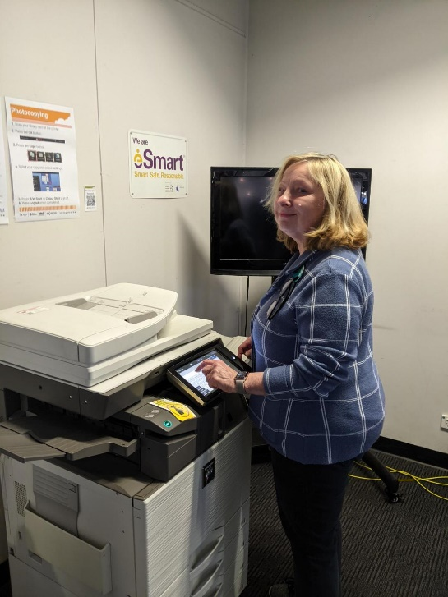
There are many public computers that people can use to access the internet.
There is free Library Public Wi-fi that I can use to access the internet on my own device. | 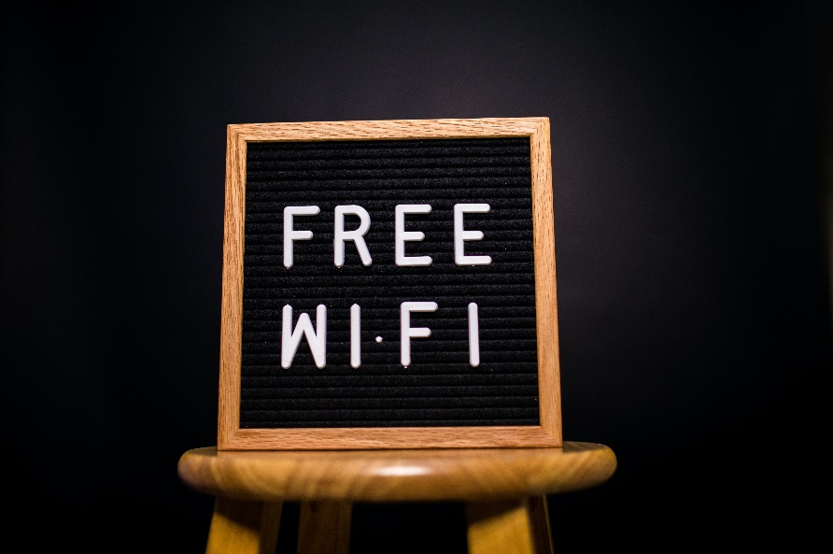
There are today’s newspapers on tables in English and other languages.  You can also find other areas to just sit quietly or read a book. | 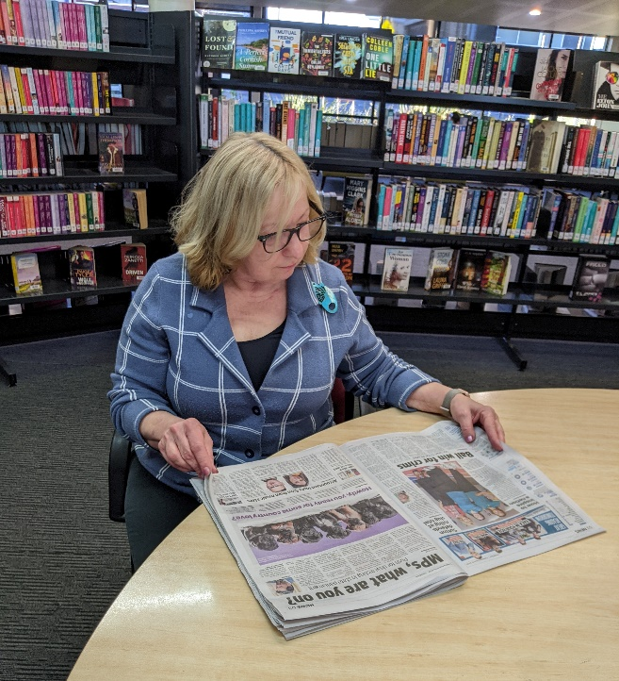
There is a Quiet Study Room that is a silent space if you need some peace and quiet. | 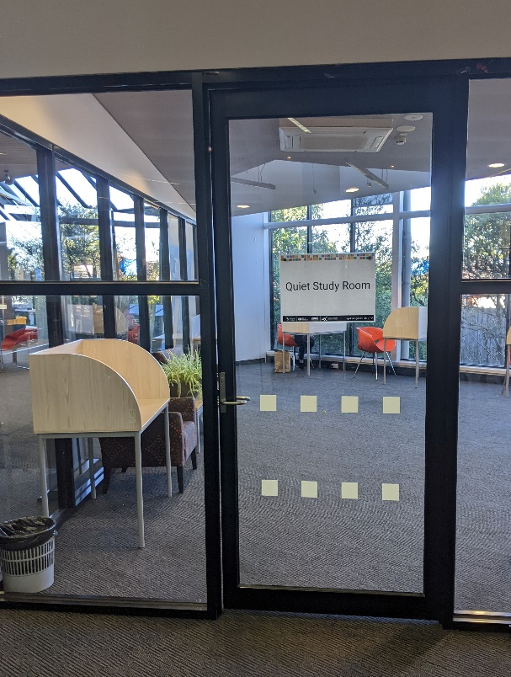
I can borrow items myself from the self-checkout machine. | 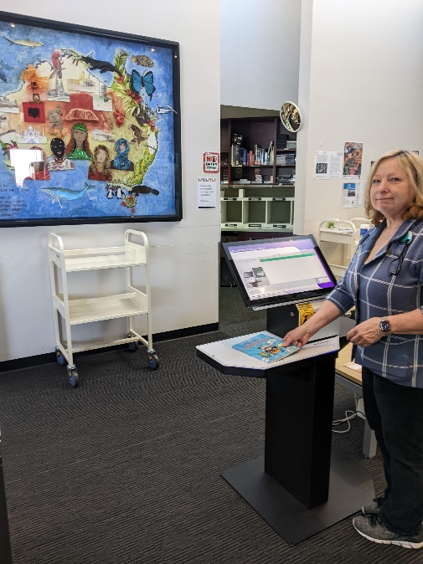
There are public toilets to the left after you pass the self-checkout machines. | 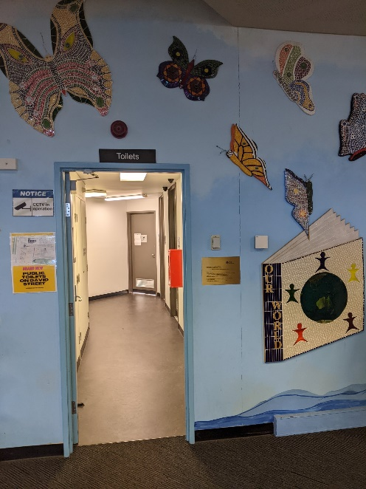
When I leave, I will say good-bye to the librarians. | 